Product Upgrade Guide v4.0.5.1

Contents
1 Document Control 3
1.1 Author 3
1.2 Document Summary 3
1.3 Document History 3
1.4 Reference documents 3
1.5 Distribution 3
1.6 Quality Assurance 3
2 Introduction 4
2.1 Purpose 4
2.2 Products Covered by this Guide 5
2.3 Order in which to Upgrade Products 5
2.4 Pre-Requisites to Upgrade 6
3 Network Manager 9
3.1 Installation of the Network Manager Software files 9
3.2 Network Manager Server Upgrade 10
3.2.1 Before you Start 10
3.2.2 Typical problems that you may encounter 10
3.2.3 Upgrade of Network Manager 10
3.2.4 Mandatory Configuration 11
3.2.5 Additional Configuration 12
3.2.6 Spatial Configuration 12
4 Street Gazetteer Manager 13
4.1 Implementation of the Street Gazetteer Manager Software files 13
4.2 Street Gazetteer Manager Server Upgrade 14
4.2.1 Before you Start 14
4.2.2 Typical problems that you may encounter 14
4.2.3 Upgrade of Street Gazetteer Manager 14
4.2.4 Mandatory Configuration 15
5 TMA Manager 16
5.1 Implementation of the TMA Manager Software files 16
5.2 TMA Manager Server Upgrade 17
5.2.1 Before you Start 17
5.2.2 Typical problems that you may encounter 17
5.2.3 Upgrade of TMA Manager 17
5.2.4 Mandatory Configuration 18
6 TMA API 25
6.1 Implementation of the TMA API Software files 25
6.2 TMA API Server Upgrade 26
6.2.1 Before you Start 26
6.2.2 Typical problems that you may encounter 26
6.3 TMA External Notice API Implementation 27
6.3.1 Deployment of API Software Files 27
6.3.2 API Server Component Install 27
7 Mapserver 29
7.1 Implementation of the Mapserver Software files 29
7.2 Mapserver Implementation 30
7.2.1 Deployment of Mapserver Software Files 30
7.2.2 Mapserver Component Install 30

- Document Control
  - Author
Exor Development

  - Document Summary
This document covers steps involved in upgrading the components for Network Manager, Street Gazetteer Manager and TMA Manager.

  - Document History

Document History
Revision | Date | By | Description
1.0 | 03-Nov-2008 | Exor Development | Draft Edition
1.1 | 10-Dec-2008 | Exor Development | First Edition

  - Reference documents
None

  - Distribution
Exor Customers, Partners and Staff

  - Quality Assurance
Document Details
File | Prepared By
0000.doc | Exor Development
Document Name | Reviewed By
Product Upgrade Guide v4.0.5.0 | Colin Stewart
Version | Approved for issue by
1.1 | Colin Stewart
Date of Issue | Support Manager
10-Dec-2008 | Graham Anns

- Introduction
  - Purpose
This guide covers steps involved in upgrading the components for
- Network Manager
- Street Gazetteer Manager
- TMA Manager
- Mapserver

Each product upgrade is split into two distinct stages,

- Stage 1 – Implementation of the Software files
- Stage 2 – Upgrade of the Server

  - Products Covered by this Guide
Table 1 lists the relevant products that are covered by this guide.

Product | Install | Upgrade From 4.0.5.0
Network Manager | ✗ | 
Street Gazetteer Manager | ✗ | 
TMA Manager | ✗ | 
Mapserver | ✗ | 
Table 1: List of products covered by this guide

  - Order in which to Upgrade Products
Table 2 lists the order in which to upgrade the products in this release.

Product to install | Order to install
Network Manager | 1
Street Gazetteer Manager | 2
TMA Manager | 3
Mapserver | N/A
Table 2: Order in which to upgrade products

  - Pre-Requisites to Upgrade
It is assumed that the audience of this document understand the configuration of the servers being upgraded and are sufficiently proficient with SQL*Plus. It is also assumed that the terminology used in this document is understood by the reader.

NB. The instructions for installation of the software describes the installation of all the software into a single area (usually referred to as the ‘Client’). The instructions for upgrading the Server (your Highways schema) assume you have access to the database from the ‘Client’.

Your configuration and server access may differ from this; the InstallShield can still be used for installation. For example, you may have to install the Client software on the Application Server and the Server software on the Database Server for reasons of database access availablilty from the Application Server.

If in any doubt please contact support@exorcorp.com.

Before attempting to upgrade, you should ensure that;

- the appropriate software components are installed and are compatible with the exor certification matrix. The certification matrix can be downloaded from the Client area of the exor website.

- all users are disconnected from the system

- the highways listener processes are not running

- a database export of the owner of Highways owner has been taken.

- You MUST copy the current <exor_base> directory and sub-directory structure and contents to a new area (e.g. <exor_base4050>). This ensures that a copy is available for backup or reference purposes should any issues arise during the installation.
The installation can then continue into a new area (e.g. <exor_install4051>) which should then be copied onto the <exor_base>.

For Example:
….copy the current <exor_base> directory and sub-directory structure and contents to a new area (e.g. <exor_base4050>)

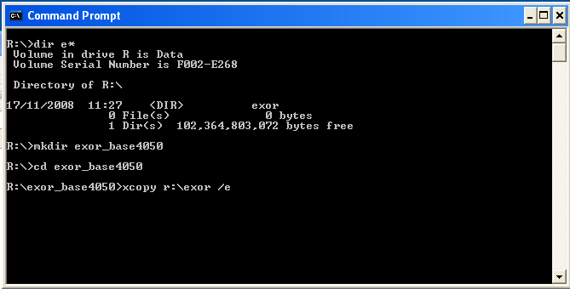

… The installation can then continue into a new area (e.g. <exor_install4051>)

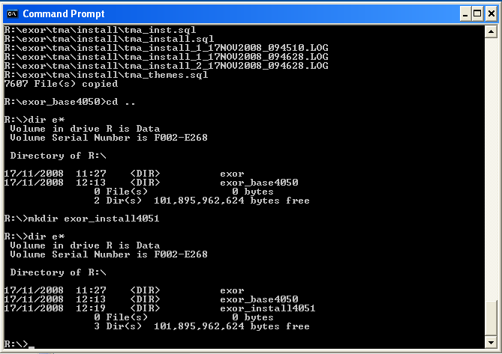

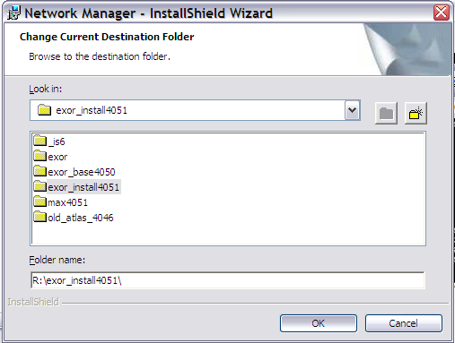

… which should then be copied onto the <exor_base>

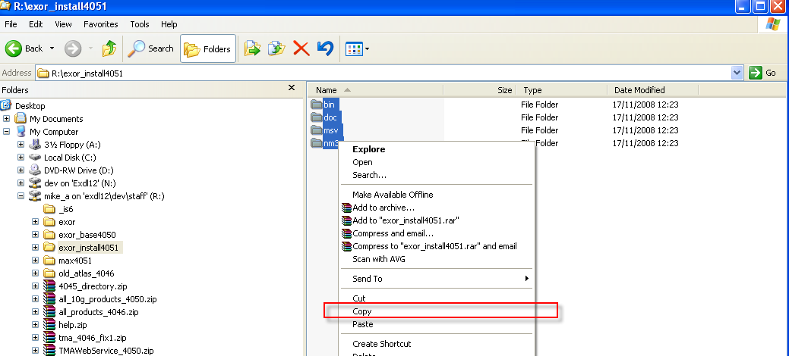

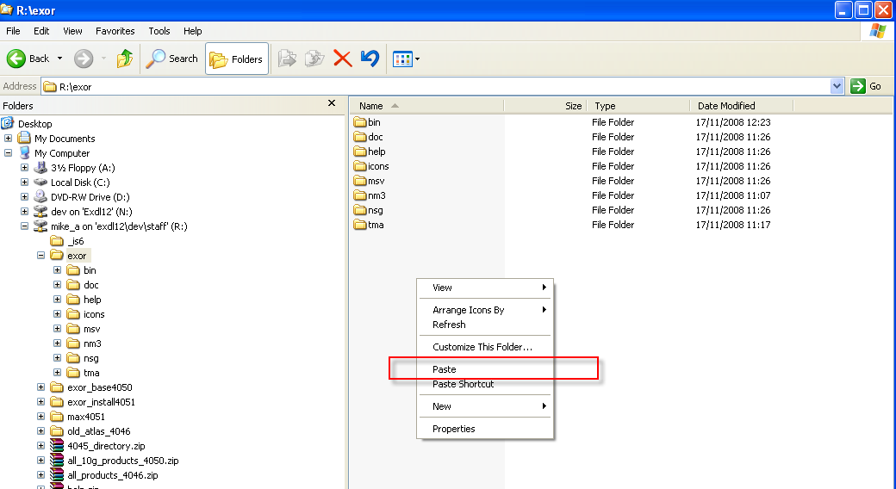

If you are upgrading the TMA Web Server also refer to page 20.

- Network Manager
  - Installation of the Network Manager Software files
To install the software components for Network Manager execute the setup_network_manager_4051.exe and follow the on-screen prompts.

Extremely Important (For TMA users):

This is a patch release to be installed on top of release 4.0.5.0

It is crucial that when selecting the ‘Destination Folder’, you select a new area and then copy that directory to the directory under which the existing 4.0.5.0 software resides (a.k.a. <exor_base>).

When the wizard completes, the necessary client and server software files will have been installed.

Notes:
A password is required to be entered during this process. If you are not sure of the password contact support@exorcorp.com.

  - Network Manager Server Upgrade
This chapter provides details of steps involved in upgrading the server components for Network Manager.

Important:
This product will require upgrading before TMA Manager and Street Gazetteer Manager.

    - Before you Start

Before proceeding please ensure that the pre-requisites mentioned in Section 2.3 of this document are met.

Also, please be aware of the following;

Where instructed to change to a directory before running a script, it is assumed that you are running SQL*PLUS from a DOS Command prompt.

If you are running SQL*PLUS in windows you should set the 'start in' directory of the SQL*PLUS shortcut to simulate the change of directory.

If you do not run SQL*PLUS from the directory stated in each step of the guide, the installation will fail.

Also, whilst following the instructions in this section you will be required to know the location of <exor_base>. You may recall that whilst undertaking the tasks in Section 3.1 you will have implemented software into the location referred to as <exor_base>, for example, C:\EXOR.

    - Typical problems that you may encounter

It is possible that, when you are running some of the upgrade scripts, errors may be reported saying that objects already exist in the database or that columns already exist on tables. These errors can generally be ignored. If you are in any doubt, please contact the Exor support desk for guidance.

The upgrade procedures will also attempt to install database roles in the highways owner account that are necessary for the system to operate correctly. You may find that errors are produced when running the upgrade scripts to the effect that the role names being created are already used by existing roles or users. These errors can be ignored as they simply mean that the roles being created already exist.

Also during upgrade Warning messages may appear saying that compilation errors have occurred. These warnings can be ignored, since invalid objects will be recompiled prompt later on in the upgrade. However it will be of concern if compilation errors still occur following the re-compilation.

    - Upgrade of Network Manager

This section describes the steps necessary to upgrade Network Manager to 4.0.5.0

Important
The server upgrade relies on invoking scripts shipped with the previous release. Therefore it is essential that the software was installed into the correct destination folder, as instructed in the previous chapter.

To upgrade the base data and objects for the Network Manager modules;

- Change directory to <exor_base>\nm3\install

- Login to SQL*PLUS as the highways owner on the client PC

- Run the following command

start nm4050_nm4051.sql

- You will be prompted to enter the path of the location of your highways software. This should be name of the directory, including disk identifier and a trailing slash character, referred to as <exor_base>.

For example, if you installed your highways software in a directory called EXOR on your C drive, you would enter the following when prompted.

C:\EXOR\

- When you have supplied this value, you will be prompted to confirm that it is correct and asked whether you wish to continue.

- If the value specified is not correct or does not end with a slash character, you will be given an error message and the installation script will abort. You will then need to login to SQL*PLUS again and rerun the script.

- When the script has completed, all the Network Manager objects and data will have been upgraded.

Checking Log File(s)

The following log files are produced in the working directory. At the end of the upgrade, they can be viewed to check for any errors that could have occurred during the upgrade process.

nm4050_nm4051_1_<date&time>.LOG
nm4050_nm4051_2_<date&time>.LOG

Log files should be emailed to support@exorcorp.com to allow exor support staff to verify the upgrade has been successful.

Due to interdependencies between some Exor products, please ignore all compilation errors until all of your products have been upgraded.

    - Mandatory Configuration

exor_version.txt

Before accessing Network Manager you must check the file exor_version.txt.

This file is referenced in Windows Registry setting ‘EXOR_VERSION’ and by default can be located in the <exor_base>\bin directory.

Ensure that the entry for Network Manager is set accordingly;

NET=4.0.5.1
HIG=4.0.5.1
AST=4.0.5.1
DOC=4.0.5.1
WMP=4.0.5.1

    - Additional Configuration

Consult the documentation that accompanies this release for details of any additional configuration that may be required following an upgrade.

For example, to obtain details of product options, and for details of new product features/amendments.

Important:
It is highly recommended that you do this before attempting to use the application.

    - Spatial Configuration

Specific information regarding the registration of spatial layers can be found in the “Locator and Web Mapping” document.

- Street Gazetteer Manager
  - Implementation of the Street Gazetteer Manager Software files
To install the software components for Street Gazetteer Manager execute the setup_street_gazetteer_manager_4051.exe and follow the on-screen prompts.

Extremely Important:

This is a patch release to be installed on top of release 4.0.5.0

It is crucial that when selecting the ‘Destination Folder’, you select a new area and then copy that directory to the directory under which the existing 4.0.5.0 software resides (a.k.a. <exor_base>).

When the wizard completes, the necessary client and server software files will have been installed.

Notes:
A password is required to be entered during this process. If you are not sure of the password contact support@exorcorp.com.

  - Street Gazetteer Manager Server Upgrade
This chapter provides details of steps involved in upgrading the server components for Street Gazetteer Manager.

Important:
This product will require upgrading after Network Manager and before TMA Manager.

    - Before you Start

Before proceeding please ensure that the pre-requisites mentioned in Section 2.3 of this document are met.

Also, please be aware of the following;

Where instructed to change to a directory before running a script, it is assumed that you are running SQL*PLUS from a DOS Command prompt.

If you are running SQL*PLUS in windows you should set the 'start in' directory of the SQL*PLUS shortcut to simulate the change of directory.

If you do not run SQL*PLUS from the directory stated in each step of the guide, the installation will fail.

Also, whilst following the instructions in this section you will be required to know the location of <exor_base>. You may recall that whilst undertaking the tasks in Section 4.1 you will have implemented software into the location referred to as <exor_base>, for example, C:\EXOR.

    - Typical problems that you may encounter

It is possible that, when you are running some of the upgrade scripts, errors may be reported saying that objects already exist in the database or that columns already exist on tables. These errors can generally be ignored. If you are in any doubt, please contact the Exor support desk for guidance.

The upgrade procedures will also attempt to install database roles in the highways owner account that are necessary for the system to operate correctly. You may find that errors are produced when running the upgrade scripts to the effect that the role names being created are already used by existing roles or users. These errors can be ignored as they simply mean that the roles being created already exist.

Also during upgrade Warning messages may appear saying that compilation errors have occurred. These warnings can be ignored, since invalid objects will be recompiled prompt later on in the upgrade. However it will be of concern if compilation errors still occur following the re-compilation.

    - Upgrade of Street Gazetteer Manager

This section describes the steps necessary to upgrade Street Gazetteer Manager to 4.0.5.1

Important
The server upgrade relies on invoking scripts shipped with the previous release. Therefore it is essential that the software was installed into the correct destination folder, as instructed in the previous chapter.

To upgrade the base data and objects for the Street Gazetteer Manager modules;

- Change directory to <exor_base>\nsg\install

- Login to SQL*PLUS as the highways owner on the client PC

- The same script is used to upgrade from the previous version shown in Section 2.2.
Run the following command

start nsg4050_nsg4051.sql

- You will be prompted to enter the path of the location of your highways software. This should be name of the directory, including disk identifier and a trailing slash character, referred to as <exor_base>.

For example, if you installed your highways software in a directory called EXOR on your C drive, you would enter the following when prompted.

C:\EXOR\

- When you have supplied this value, you will be prompted to confirm that it is correct and asked whether you wish to continue.

- If the value specified is not correct or does not end with a slash character, you will be given an error message and the installation script will abort. You will then need to login to SQL*PLUS again and rerun the script.

- When the script has completed, all the Street Gazetteer Manager objects and data will have been upgraded.

Checking Log File(s)

The following log files are produced in the working directory. At the end of the upgrade, they can be viewed to check for any errors that could have occurred during the upgrade process.

nsg4050_nsg4051_1_<date&time>.LOG
nsg4050_nsg4051_2_<date&time>.LOG

Log files should be emailed to support@exorcorp.com to allow exor support staff to verify the upgrade has been successful.

Due to interdependencies between some Exor products, please ignore all compilation errors until all of your products have been upgraded.

    - Mandatory Configuration

exor_version.txt

Before accessing Street Gazetteer Manager you must check the file exor_version.txt.

This file is referenced in Windows Registry setting ‘EXOR_VERSION’ and by default can be located in the <exor_base>\bin directory.

Ensure that the entry for Street Gazetteer Manager is set accordingly;

NSG=4.0.5.1

- TMA Manager
  - Implementation of the TMA Manager Software files

To install the software components for TMA Manager execute the setup_tma_manager_4050.exe and follow the on-screen prompts.

Extremely Important:

This is a patch release to be installed on top of release 4.0.5.0

It is crucial that when selecting the ‘Destination Folder’, you select a new area and then copy that directory to the directory under which the existing 4.0.5.0 software resides (a.k.a. <exor_base>).

When the wizard completes, the necessary client and server software files will have been installed.

Notes:
A password is required to be entered during this process. If you are not sure of the password contact support@exorcorp.com.

  - TMA Manager Server Upgrade
This chapter provides details of steps involved in upgrading the server components for TMA Manager.

Important:
This product will require upgrading after Network Manager and Street Gazetteer Manager.

    - Before you Start

Before proceeding please ensure that the pre-requisites mentioned in Section 2.3 of this document are met.

Also, please be aware of the following;

Where instructed to change to a directory before running a script, it is assumed that you are running SQL*PLUS from a DOS Command prompt.

If you are running SQL*PLUS in windows you should set the 'start in' directory of the SQL*PLUS shortcut to simulate the change of directory.

If you do not run SQL*PLUS from the directory stated in each step of the guide, the installation will fail.

Also, whilst following the instructions in this section you will be required to know the location of <exor_base>. You may recall that whilst undertaking the tasks in Section 5.1 you will have implemented software into the location referred to as <exor_base>, for example, C:\EXOR.

    - Typical problems that you may encounter

It is possible that, when you are running some of the upgrade scripts, errors may be reported saying that objects already exist in the database or that columns already exist on tables. These errors can generally be ignored. If you are in any doubt, please contact the Exor support desk for guidance.

The upgrade procedures will also attempt to install database roles in the highways owner account that are necessary for the system to operate correctly. You may find that errors are produced when running the upgrade scripts to the effect that the role names being created are already used by existing roles or users. These errors can be ignored as they simply mean that the roles being created already exist.

Also during upgrade Warning messages may appear saying that compilation errors have occurred. These warnings can be ignored, since invalid objects will be recompiled prompt later on in the upgrade. However it will be of concern if compilation errors still occur following the re-compilation.

    - Upgrade of TMA Manager

This section describes the steps necessary to upgrade TMA Manager to 4.0.5.1

Important
The server upgrade relies on invoking scripts shipped with the previous release. Therefore it is essential that the software was installed into the correct destination folder, as instructed in the previous chapter.

To upgrade the base data and objects for the TMA Manager modules;

- Change directory to <exor_base>\tma\install

- Login to SQL*PLUS as the highways owner on the client PC

- The same script is used to upgrade from the previous version shown in Section 2.2.
Run the following command

start tma4050_tma4051.sql

- You will be prompted to enter the path of the location of your highways software. This should be name of the directory, including disk identifier and a trailing slash character, referred to as <exor_base>.

For example, if you installed your highways software in a directory called EXOR on your C drive, you would enter the following when prompted.

C:\EXOR\

- When you have supplied this value, you will be prompted to confirm that it is correct and asked whether you wish to continue.

- If the value specified is not correct or does not end with a slash character, you will be given an error message and the installation script will abort. You will then need to login to SQL*PLUS again and rerun the script.

- When the script has completed, all the TMA Manager objects and data will have been upgraded.

Checking Log File(s)

The following log files are produced in the working directory. At the end of the upgrade, they can be viewed to check for any errors that could have occurred during the upgrade process.

tma4050_tma4051_1_<date&time>.LOG
tma4050_tma4051_2_<date&time>.LOG

Log files should be emailed to support@exorcorp.com to allow exor support staff to verify the upgrade has been successful.

Due to interdependencies between some Exor products, please ignore all compilation errors until all of your products have been upgraded.

    - Mandatory Configuration

exor_version.txt

Before accessing TMA Manager you must check the file exor_version.txt.

This file is referenced in Windows Registry setting ‘EXOR_VERSION’ and by default can be located in the <exor_base>\bin directory.

Ensure that the entry for TMA Manager is set accordingly;

TMA=4.0.5.1

Web Services

Receiving Transactions

A batch job must be created that will validate and process incoming XML received by the Web Service and translate into Notices and Works, etc.

A DBMS job must be executed at regular intervals to process transactions received by the Web Service. Login to SQL*Plus as the “exor highways owner” and run the following commands to process transactions at x minute intervals (nb. x should be substituted for the desired number of minutes interval at which the job will execute):

begin
tma.submit_transaction_job(x);
end;
/

Sending Transactions

A batch job must be created that will validate and process the Transactions that are waiting to be sent out before the Web Service sends them.

A DBMS job must be executed at regular intervals to process transactions sent by the Web Service. Login to SQL*Plus as the “exor highways owner” and run the following commands to process transactions at x minute intervals (nb. x should be substituted for the desired number of minutes interval at which the job will execute):

begin
tma.submit_transaction_send_job(x);
end;
/

Inspections Uploading

A DBMS job can be executed at regular intervals to upload TMA inspections files. This can be used as an alternative to manually uploading the files through the system. Login to SQL*Plus as the “exor highways owner” and run the following commands to process uploads at x minute intervals (nb. x should be substituted for the desired number of minutes interval at which the job will execute):

begin
tma.submit_inspections_upload_job(x);
end;
/

Archived Works/Sites

A DBMS job can be executed on a daily basis to copy the data out of the SWM tables and into TMA_ARCHIVED_WORKS and TMA_ARCHIVED_SITES. This job will insert new works/sites and update existing works/sites and will run at 23:00 on a daily basis.
Login to SQL*Plus as the "exor highways owner", At the prompt type START create_job_to_populate_taw_tas_from_swm.sql and press return.

start create_job_to_populate_taw_tas_from_swm.sql;
/
ApEx

Log onto the ApEx application.

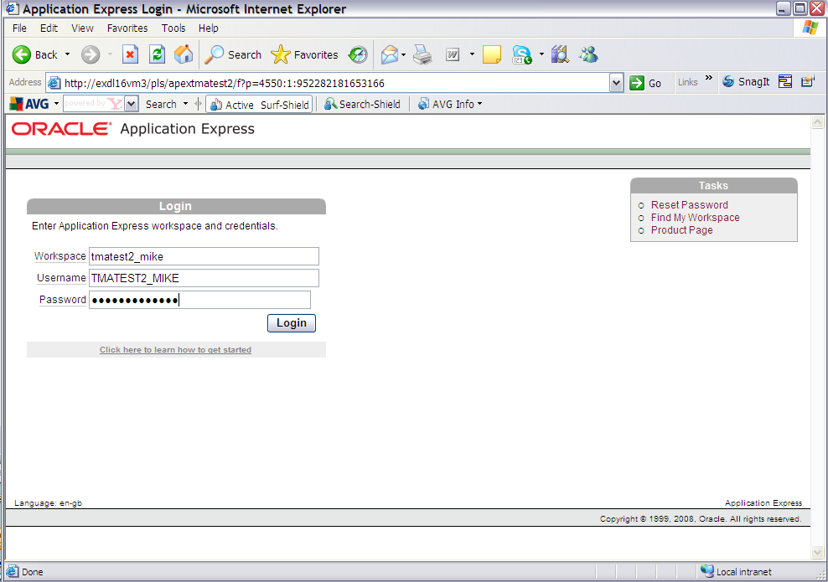

Select the 'Application Builder' option and import

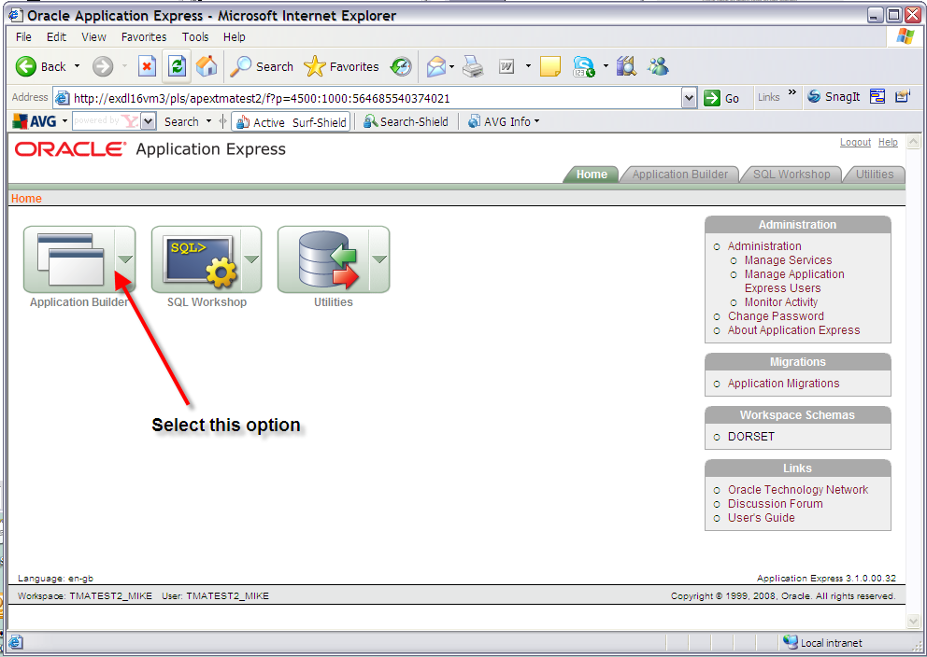

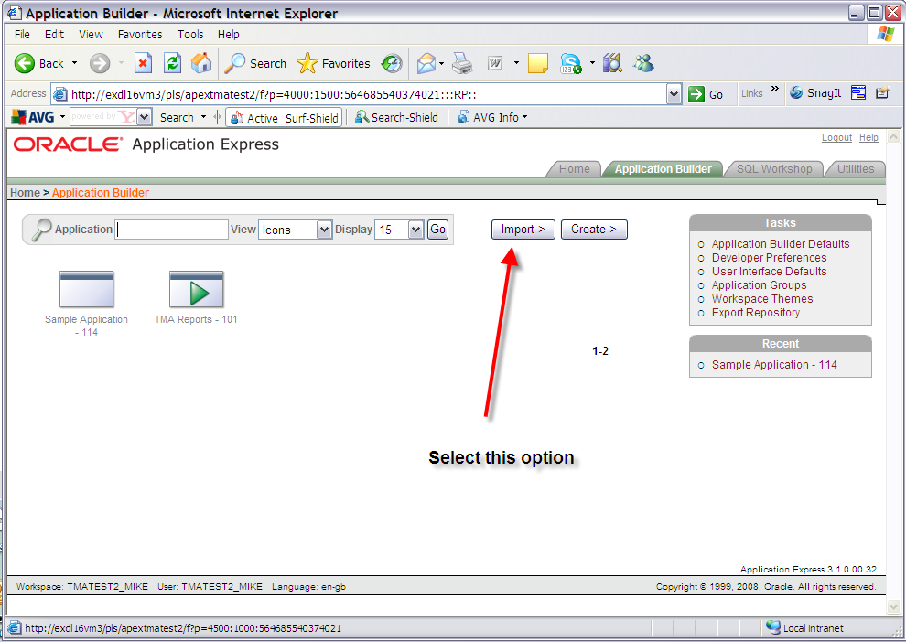

Import the ApEx Reports file under the directory <exor_base>\tma\admin\sql\tma_apex_rpts.sql

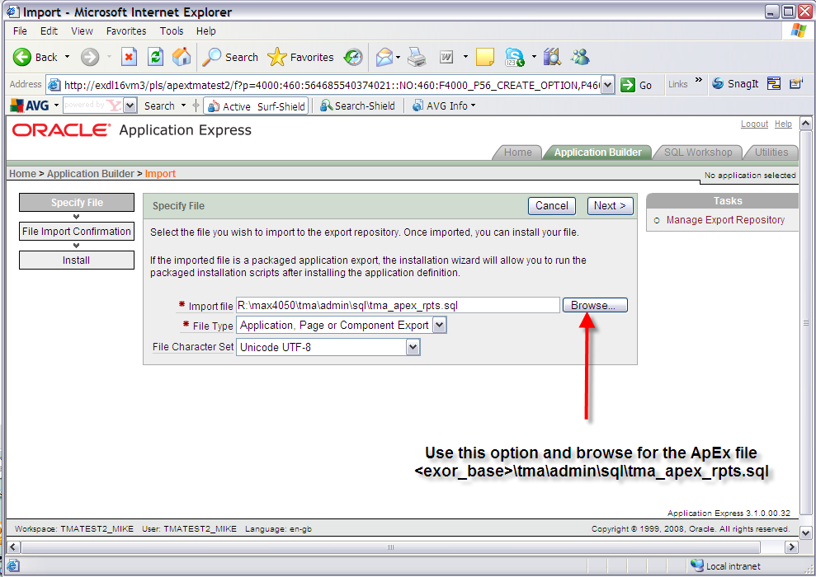

Once the file has been imported you will be met with this screen. Click the next button to proceed.

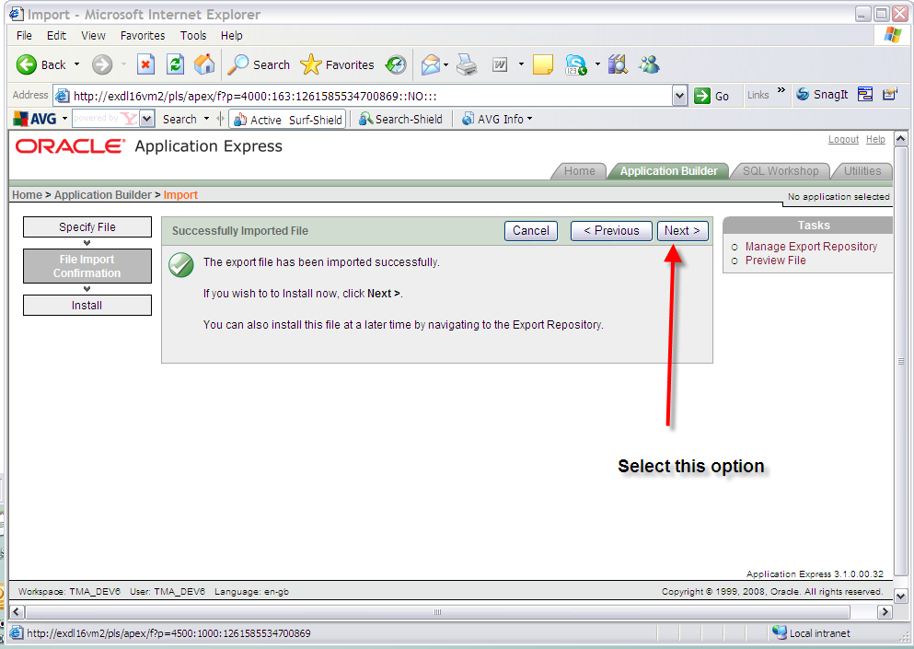

On the install application screen, which should be the screen presented, in the 'Install As Application' option select the 'Reuse Application ID 101 From Export' option and click the Install button. Parsing schema and build status should default values. Ensure that the Parsing Schema is the correct schema and the build status is ‘Run Application Only’.

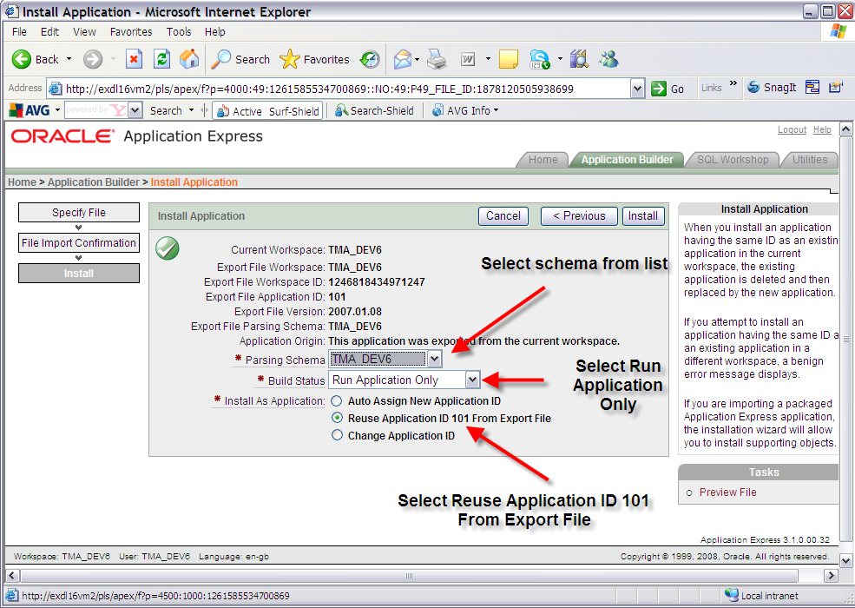

Click the Install button:

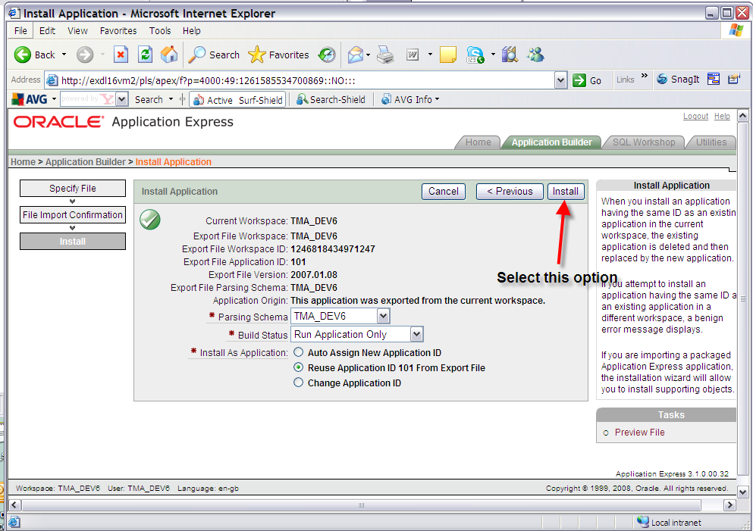

You should be presented with a 'Confirm Replace Application' screen. Click the 'Replace Existing Application' button.

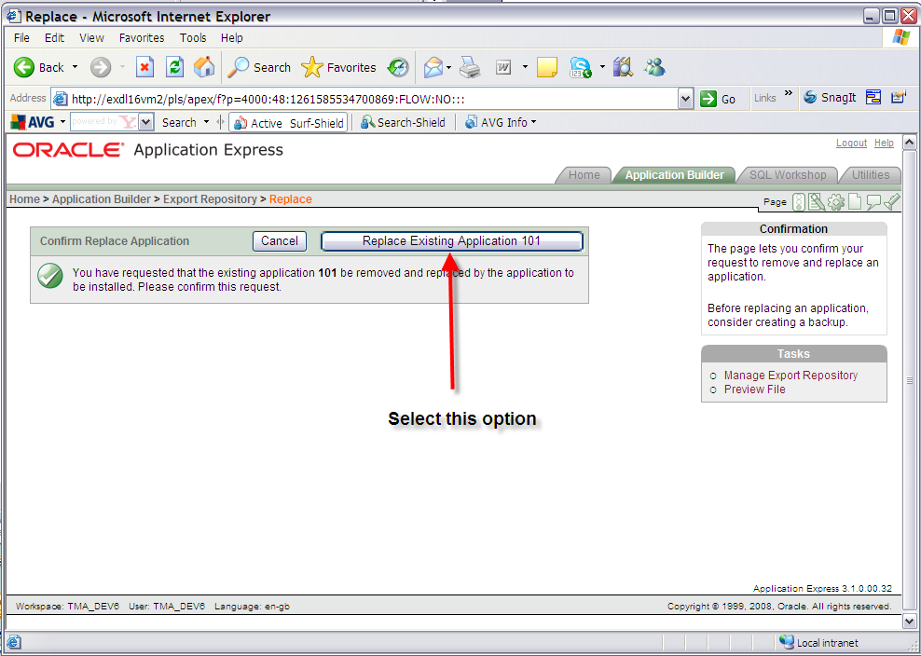

Exit the window which should read 'Application not available for edit'.

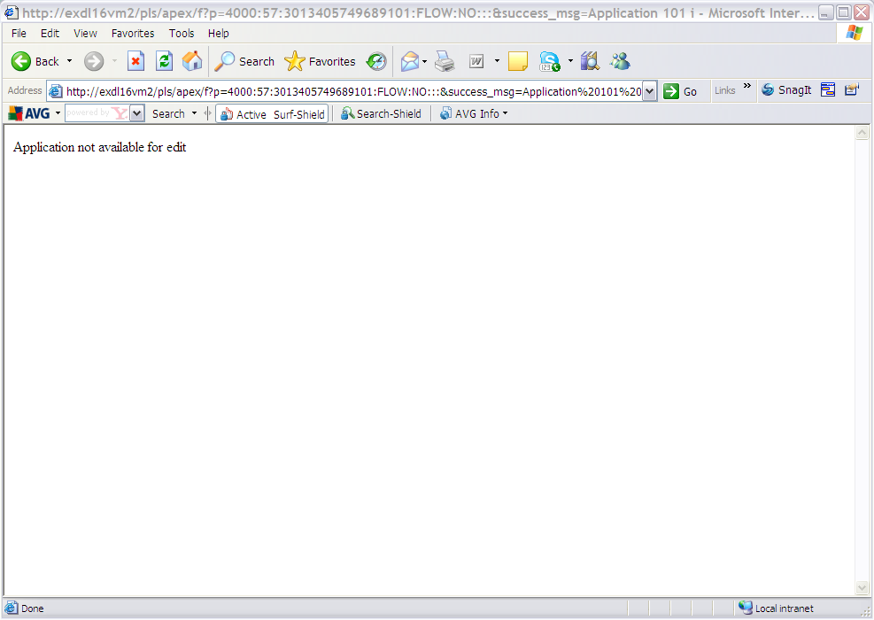

Test the reports from the TMA application.

- TMA API
  - Implementation of the TMA API Software files

To install the software components for TMA Manager execute the setup_tma_api_4051.exe and follow the on-screen prompts.

Extremely Important:

This is a patch release to be installed on top of release 4.0.5.0

It is crucial that when selecting the ‘Destination Folder’, you select a new area and then copy that directory to the directory under which the existing 4.0.5.0 software resides (a.k.a. <exor_base>).

When the wizard completes, the necessary client and server software files will have been installed.

Notes:
A password is required to be entered during this process. If you are not sure of the password contact support@exorcorp.com.

  - TMA API Server Upgrade
This chapter provides details of steps involved in upgrading the server components for TMA Manager.

Important:
This product will require upgrading after Network Manager, Street Gazetteer Manager and TMA Manager.

    - Before you Start

Before proceeding please ensure that the pre-requisites mentioned in Section 2.3 of this document are met.

Also, please be aware of the following;

Where instructed to change to a directory before running a script, it is assumed that you are running SQL*PLUS from a DOS Command prompt.

If you are running SQL*PLUS in windows you should set the 'start in' directory of the SQL*PLUS shortcut to simulate the change of directory.

If you do not run SQL*PLUS from the directory stated in each step of the guide, the installation will fail.

Also, whilst following the instructions in this section you will be required to know the location of <exor_base>. You may recall that whilst undertaking the tasks in Section 6.1 you will have implemented software into the location referred to as <exor_base>, for example, C:\EXOR.

    - Typical problems that you may encounter

It is possible that, when you are running some of the upgrade scripts, errors may be reported saying that objects already exist in the database or that columns already exist on tables. These errors can generally be ignored. If you are in any doubt, please contact the Exor support desk for guidance.

The upgrade procedures will also attempt to install database roles in the highways owner account that are necessary for the system to operate correctly. You may find that errors are produced when running the upgrade scripts to the effect that the role names being created are already used by existing roles or users. These errors can be ignored as they simply mean that the roles being created already exist.

Also during upgrade Warning messages may appear saying that compilation errors have occurred. These warnings can be ignored, since invalid objects will be recompiled prompt later on in the upgrade. However it will be of concern if compilation errors still occur following the re-compilation.

  - TMA External Notice API Implementation
    - Deployment of API Software Files

This section provides details of steps involved in deploying the files that the api is composed of to the relevant location on the file system.

Important:
All Exor applications that you install must go into the same destination – what is often referred to as <exor_base>.

To deploy the software components for the api, execute the setup_tma_api.exe and follow the on-screen prompts.

When the wizard completes, the necessary software files will have been deployed. These are held in the API directory. Copy the API folder and contents to the tma\admin folder.

    - API Server Component Install

This section provides details of steps involved in installing the server components for api.

Note, that there is no upgrade option; the software can be reinstalled as required.

Important:
The api will require installing after the TMA application.

Also please be aware of the following;

Where instructed to change to a directory before running a script, it is assumed that you are running SQL*PLUS from a DOS Command prompt.

If you are running SQL*PLUS in windows you should set the 'start in' directory of the SQL*PLUS shortcut to simulate the change of directory.

If you do not run SQL*PLUS from the directory stated in each step of the guide, the installation will fail.

Also, whilst following the instructions in this section you will be required to know the location of <exor_base>.

To create the base data and objects for api;

Change directory to <exor_base>\tma\admin\api

Login to SQL*PLUS as the highways owner on the client PC and run the following command

start tma_api_inst.sql

You will be prompted to enter the path of the location of your highways software. This should be name of the directory, including disk identifier and a trailing slash character, referred to as <exor_base>.

For example, if you installed your highways software in a directory called EXOR on your C drive, you would enter the following when prompted.

C:\EXOR\

When you have supplied this value, you will be prompted to confirm that it is correct and asked whether you wish to continue.

If the value specified is not correct or does not end with a slash character, you will be given an error message and the installation script will abort. You will then need to login to SQL*PLUS again and rerun the script.

When the script has completed, the api will have been installed.

Checking Log File(s)

The following log file is produced in the working directory. At the end of the installation, the file can be viewed to check for any errors that could have occurred during installation.

tma_api_install_<date&time>.LOG

Note:
If there are any queries regarding the results of the install then the Log file should be emailed to support@exorcorp.com to allow Exor support staff to verify the install has been successful.
- Mapserver
  - Implementation of the Mapserver Software files

To install the software components for Mapserver execute the setup_mapserver_4051.exe and follow the on-screen prompts.

Extremely Important:

This is a patch release to be installed on top of release 4.0.5.0

It is crucial that when selecting the ‘Destination Folder’, you select a new area and then copy that directory to the directory under which the existing 4.0.5.0 software resides (a.k.a. <exor_base>).

When the wizard completes, the necessary client and server software files will have been installed.

Notes:
A password is required to be entered during this process. If you are not sure of the password contact support@exorcorp.com.

  - Mapserver Implementation
    - Deployment of Mapserver Software Files

This section provides details of steps involved in deploying the files that Mapserver is composed of to the relevant location on the file system.

Important:
All Exor applications that you install must go into the same destination – what is often referred to as <exor_base>.

To deploy the software components for the api, execute the setup_mapserver_4051.exe and follow the on-screen prompts.

When the wizard completes, the necessary software files will have been deployed.

    - Mapserver Component Install

Locate the <exor_base>\msv\exorMapviewer4051 where you will find exorMapviewer4051.jar. Copy this file to <oracle_home>\mid\forms\java.

The formsweb.cfg file, located at <oracle_home>\mid\forms\server, will need editing. Replace occurances of exorMapviewer40461.jar with exorMapviewer4051.jar

Once the upgrade of the test and/or live system has taken place. There are usually two lines per entry (test and live)

eg:
currently

pjcArchive=frmall.jar,exor_jpg.jar,UploadClient.jar,UploadClient.jar.sig,exorMapviewer40461.jar,mvclient_9i.jar
archive_jini=exor_jpg.jar,exorMapviewer40461.jar,frmall.jar,mvclient_9i.jar,UploadClient.jar,UploadClient.jar.sig

post upgrade

pjcArchive=frmall.jar,exor_jpg.jar,UploadClient.jar,UploadClient.jar.sig,exorMapviewer4050.jar,mvclient_9i.jar
archive_jini=exor_jpg.jar,exorMapviewer4051.jar,frmall.jar,mvclient_9i.jar,UploadClient.jar,UploadClient.jar.sig

Save the file and exit.

On each client machine the Jar Cache will need to be cleared. This can be done by the following methods.

Oracle Jinitiator users

Start-> Settings-> Control Panel-> Jinitiator 1.3.1.22. Navigate to the "Cache" tab and click "Clear JAR Cache"

Sun JRE users

Start-> Settings-> Control Panel-> Java. Navigate to the "General" tab and click "Settings" button. In the Disk Space section click "Delete Files" button

You should now load the exor application in the usual way. On the first load, it will take longer than usual whilst the JAR files are cached again.

